SCAC Congregation Information Update Form
PLEASE READ THIS CAREFULLY
==========
- The purpose of collecting/updating the congregations’ data is crucial and allow SCAC to communicate and manage our congregations effectively. All the data that you have provided will be strictly for SCAC internal use only.
- The fields marked with “*” are required, if you have any concern of providing those information, please contact either Sabina Hung (sabinahung@scacseattle.org) or Betty Wong (bettywong@scacseattle.org) before completing the form.
- When completing the form, please include all your family members, including spouse and children (if they attend SCAC Sunday School and Junior Worship). By doing that, our system will be able to link all the members into a single “Family”. You can add another member by clicking the “Add another family member” link at the bottom of the form.
- The "School Grade" and the "Date of Birth" are only for the children's entry. If you don't have any children in your household, please ignore them.
Please visit the following URL or use the QR Code to complete your family data:

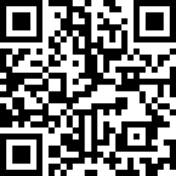

https://tinyurl.com/scac-members-form

